# Journals

* Estuaries & Coasts <https://www.springer.com/journal/12237/submission-guidelines>
  + The journal covers research on physical, chemical, geological or biological processes, as well as applications to management of estuaries and coasts. Submissions that are primarily descriptive, strongly place-based, or only report on development of models or new methods **without detailing their applications** fall outside the scope of the journal.
* Restoration Ecology (NAS publishes in this one a lot, hesitancy to target first). <https://onlinelibrary.wiley.com/page/journal/1526100x/homepage/productinformation.html>
  + Original papers describe experimental, observational, and theoretical studies on terrestrial, marine, and freshwater systems, and are considered without taxonomic bias. Contributions span the natural sciences, including ecological and biological aspects, as well as the restoration of soil, air and water when set in an ecological context …
  + ***RESEARCH ARTICLES*** (< 8000 words) present research on restoration and ecological principles that help explain restoration processes, management, policy, governance, or socio-ecological aspects of restoration ecology. These articles will have a deep theoretical framework and be more generalizable. They will usually be longer-term studies with, for example, larger sample sizes, replicates, or other designs that allow that generalization. These papers can include systematic discussions of unexpected outcomes, setbacks, and failures in research.
    - **Q1, $3300 USD OA**

Estuary marsh habitat recovery following intensive grazing by an non-native herbivore

# Abstract

Cumulative threats are impacting estuaries globally. Legacies of human alterations to the landscape leave habitat vulnerable to natural disturbance such has overgrazing. In the Pacific Northwest of North America, resident hyper-abundant populations of non-native Canada geese (*Branta canadensis*, “CAGO”) are leading to estuary marsh habitat degradation.  As land and resource managers grapple with how to manage these impacts, our research highlights the trajectory of marsh recovery and reveals that non-native plant species are poised to recolonize degraded marsh ecosystems following CAGO removal. After 10 years of passive recovery, we found abundance of non-native grasses were XX more abundant in the above-ground vegetation, and YY more abundant in the surface seed bank compared to ungrazed sites. [compare to 1 yo or denuded sites?] [Mgmt implications]

# Introduction

Cumulative impacts of landscape-scale disturbance are threatening ecosystem function of estuaries around the world (CITE). Natural disturbance is inherent to the development and maintenance of estuary ecosystems (CITE), however disturbance caused by humans has led to novel sources, intensities, frequencies, and combinations of press and pulse disturbance (CITE). Examples of anthropogenic press disturbances include land use conversion of estuarine floodplains to impervious cover (Finn et al., 2021), and global impacts of climate change such as altered hydrology or phenological networks (CITE). Ecological consequences of these press disturbances include biodiversity loss or homogenization of species composition (CITE), which are readily exemplified in the literature (CITE, CITE, Lane *et al*., submitted). These ongoing stressors subsequently reduce estuary ecosystem resistance or resilience to intensive pulse disturbances, such as storm surges or overgrazing (CITE).

Passive ecological recovery through successional processes is able to proceed with the release of disturbance pressure (CITE). However, biodiversity loss and homogenization from pulse or press stressors may have shifted the compositional abundance of populations available to repopulate the community (CITE), and increases the potential for novel species to become abundant through recruitment into newly available niches (CITE). Competition is one process that drives species dominance within a community (MacArthur, 1958). Post-disturbance changes in community-dominant species composition may be driven by competitive strategies, resulting in successional trajectories alternative to the historical ecosystem context (Muench & Elsey‐Quirk, 2019; Tilman, 2004). A key knowledge gap is understanding how competitive strategies lead to alternative post-disturbance succession in estuaries.

Recovery of estuary vegetation is dependent upon propagules remaining within the disturbed area in the form of seed banks or clonally reproductive individuals at the edges of the disturbed area, or dispersed from outside the disturbed area. In estuaries, clonal vegetative fragments or seeds can be dispersed from within the same estuary (CITE), from the upstream watershed (CITE), or by intertidal dispersal from other estuaries (CITE, CITE, CITE). Each of these dispersal pathways may deliver propagules that are not representative of the historical species composition, creating opportunities for new, estuary-adapted species to competitively dominate the recovering plant community. The ecological memory of historical community composition may be shaped by the historic competitive strategies of the dominant species, and feedbacks between parent plant and seed bank linkages (CITE). Plants may exhibit different competitive advantages through alternative reproductive strategies, such as clonal reproduction or heavy seed production. Tradeoffs exist, however, such as highly competitive clonal reproduction at expense of seed limitation (e.g., *Carex lyngbyei*; CITE). Or, plants may have equally strong clonal and seed reproductive capability, increasing the species’ opportunity for community dominance (e.g., non-native sp.; CITE). Should a species’ competitive strategy (seed or clonal) be removed from the community during a disturbance event, then recovery of that species via succession would be influenced by the relative competitive advantage of remaining propagative material in the disturbed area. The reproductive strategies of a plant community may thus affect an ecosystem’s resilience and whether it returns to a compositional state similar to pre-disturbance conditions (Standish et al., 2014). Anthropogenic legacy impacts such as landscape introduction of non-native species and their respective competitive strategies may derail an historical recovery trajectory, pushing the ecosystem to a novel assemblage (CITE).

Ecosystem consequences of non-native species introductions by humans are well documented (CITE, CITE, CITE). Canada goose (*Branta canadensis*, “CAGO”) was historically an infrequent migrant to the Pacific Northwest of North America, but in the later 20th century, resident populations were introduced to Vancouver Island promote hunting tourism (CITE), and have since become regionally hyperabundant (CITE). In estuaries, CAGO grazing behavior is particularly concerning not only because they heavily graze the leafy above-ground vegetation, but they “grub” or rip out the rhizomes that would be capable of clonally growing to restore the vegetation after grazing (CITE). Subsequent sediment erosion leads to loss of seed banks along with the loss of above- and below-ground vegetation, effectively creating mudflats and resetting succession. Early succession favors ruderal species driven by seed recruitment, resulting in strong similarities in dominant species in the vegetation and the most recent seed inputs to the sediment (surface seed banks) (CITE). In many ecosystems including wetlands and estuaries, dissimilarity of seed banks and parent vegetation increases with greater time since disturbance (Hopfensperger, 2007). Older, climax succession (Clements, 1916) can be exemplified in Pacific Northwest estuaries by the dominance of tall, perennial graminoids (TPGs). These species include rushes, sedges, and grasses with competitive clonal reproductive strategies, although not all species are as strongly competitive by seed production and recruitment (CITE). Restoration efforts employ exclosures to physically prevent CAGO from continuing to graze and grub vegetation (CITE?), with the expectation that successional processes will facilitate passive recovery to an historical compositional abundance in the plant community. However, in an ecosystem experiencing various ongoing disturbance pressures, novel propagule inputs may

The main objective of this study was to understand compositional changes of surface seed banks and above-ground vegetation at discrete stages of recovery since grazing exclusion in two Salish Sea estuaries. We wanted to know if grazing exclusion allows species to passively recover to a compositional abundance similar to undisturbed sites. Traditional succession models would say the most competitive species will increasingly dominate the plant community as time since disturbance increases. This would particularly be the case in a clonal ecosystem, where recovery is driven by species spreading clonally from adjacent undisturbed sites, in addition to potential recruitment from the seed bank. If succession is happening the we expect:

1. Above-ground vegetation at older disturbance sites will be more similar to reference vegetation than recently disturbed (regardless of seed inputs), with respect to compositional abundance of tall, perennial graminoids (TPGs) which dominate this ecosystem.
   1. Alternatively, novel disturbance and novel seed inputs lead to alternative succession pathways, where new competitors from seed inputs derail the "slow encroachment" of the clonal dominant from the neighboring intact site.
2. Above-ground vegetation in recently disturbed sites will be highly similar to seed inputs than older disturbance vegetation similarity to seed, or reference vegetation similarity to seed, especially with respect to compositional abundance of TPGs.

From a conservation and land management perspective, we should be cognizant of long-term grazing impacts on recovery of plant communities and the implications for alternate successional trajectories. This is especially the case in ecosystems such as estuaries, which experience sustained press and intensive pulse disturbances from natural and anthropogenic sources.

# Methods

## Study area & site history

The Little Qualicum River Estuary (LQRE) and Nanaimo River Estuary (NRE) are situated on the east coast of Vancouver Island along the Strait of Georgia (Figure 1), and are unceded territory of the K’omoks, Snuneymuxw, Qualicum, and Nanoose Nations. Prior to European colonial settlement, these estuaries would have been traditionally managed as root gardens to promote the abundance of broadleaf flowering species with starchy roots, rather than the tall, perennial graminoids that dominate the estuaries today (Turner, Lepofsky, & Deur, 2013).

The LQRE was designated as a Wildlife Management Area (WMA) in YYYY, while NRE was designated as a Wildlife Refuge in YYYY. Because these designations confer protection of wildlife habitat, they have been heavily utilized by resident and migratory waterfowl including CAGO (PECP Estuary Ranking, 2021). Observation of intensive grazing in the LQRE led to the establishment of exclosures in 2010 as a trial method to prevent herbivory (DAWE). Local conservation group Guardians of Our Salish Estuaries (formerly Guardians of Mid-Island Estuary Society) continued exclosure construction in both estuaries, opportunistically protecting channel edges where herbivory was most intensive to prevent further loss of habitat (FIG). Exclosures included in this study were selected to represent comparable disturbance conditions at the time of exclosure construction. Despite efforts to protect marsh and channel edge habitat, herbivory is ongoing and areas of habitat degraded by excessive grazing/grubbing remain; grubbed sites selected for comparison were not protected by an exclosure during the study period. Within each estuary, ungrazed habitat is typically found further upstream along tidal channels or interior to the channel edge, and were not protected by exclosures during the study period.

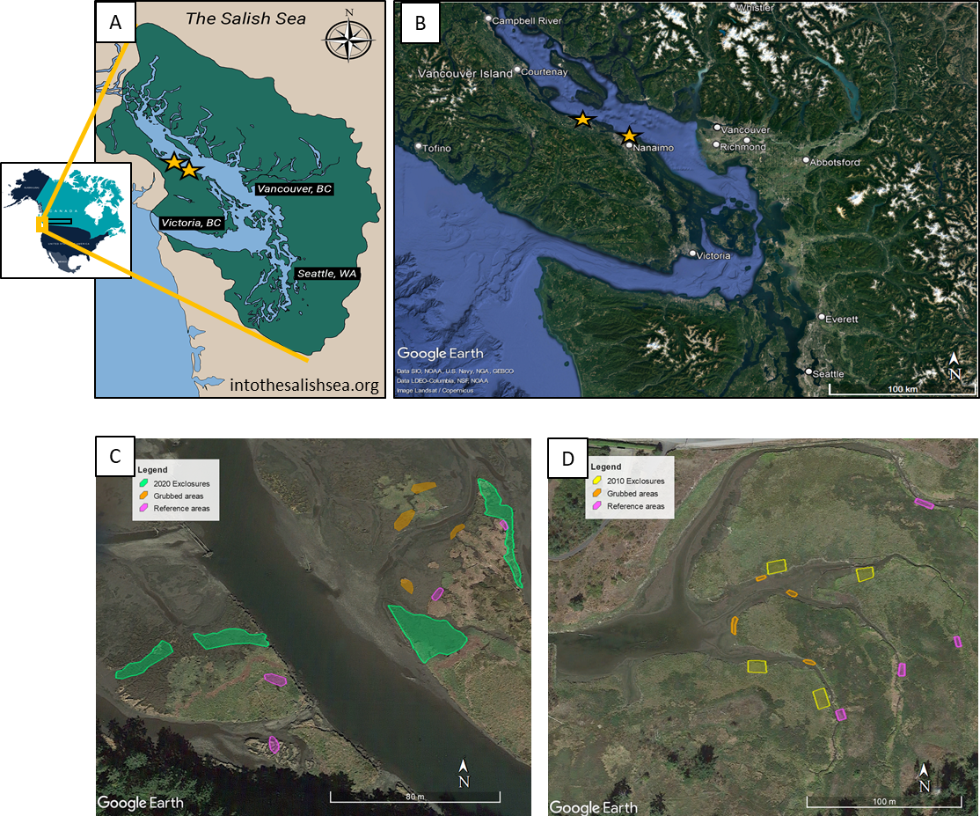

Figure . The Salish Sea spans the US-Canadian border on the Pacific Coast of North America (A). Two estuaries located on the southeastern coast of Vancouver Island (B) were surveyed where grazing disturbance and recovery were observed in the Nanaimo River Estuary (C) and Little Qualicum River Estuary (D).

Table . Grazing disturbance conditions in the Little Qualicum River and Nanaimo Estuaries resulted in conversion of vegetated marsh to partially or fully grubbed mudflats; exclosures were installed to prevent further degradation into the marsh platform. Each estuary sampled n = 4 sites for disturbance category. Two 1 m2 plots were sampled within each site, and two surface seed banks samples were taken from each plot.

|  |  |  |  |  |  |  |  |
| --- | --- | --- | --- | --- | --- | --- | --- |
| **Estuary** | **Time Since Disturbance** | **Disturbance condition** | **Revegetation status** | **Protected by exclosure?** | **Number of sites (exclosures, or comparably sized area)** | **Number of sampling plots per site** | **Number of surface seed bank samples per plot** |
| Little Qualicum, Nanaimo | 0 years (recent grubbing disturbance) | Grubbed | No manipulations | No | 8 | 2 | 2 |
| Nanaimo | 1-year post-grazing/grubbing disturbance | Partially grubbed | No transplants; vegetation recovery from remnant and adjacent vegetation | Yes | 4 | 2 | 2 |
| Little Qualicum | 10 years post-grazing/grubbing disturbance | Partially grubbed | No transplants; vegetation recovery from remnant and adjacent vegetation | Yes | 4 | 2 | 2 |
| Little Qualicum, Nanaimo | No known grazing disturbance | Undisturbed | No manipulations | No | 8 | 2 | 2 |

## Sampling methods

### Vegetation sampling

Vegetation sampling was conducted once in mid-July, 2021. Two 1 m2 vegetation plots were placed within the exclosures (sites, n = 4 per estuary), at least 1 m from the bank edge and any exclosure boundary, and at least 3 m apart within the exclosure. Quadrats were placed so that the plot edge nearest creek was parallel to the bank.

All vascular species were identified according Hitchcock and Cronquist (1973), and currently accepted nomenclature standardized according to the PLANTS Database of the United States Department of Agriculture, Natural Resources Conservation Science [USDA NRCS]. Species were considered in the plot if at least half of their basal stem(s) were inside the quadrat boundary; overhanging vegetation originating from basal stems outside the plot was not considered. Aerial vegetated cover was estimated to the nearest 3 % (1/32 m2). For any species present with less than 3 % cover, species were assigned 2% cover if > 20 individuals were present, 1 % cover if 2-20 individuals were present, and 0.1% cover for single individuals. Bare ground was estimated as the remainder of the plot area not covered by above-ground vegetation. Any plots with > 100% cover were standardized relative to 100%. To characterize plant structure, species were assigned to a height category tall (> 1 m), medium (50-100 cm), or short (< 50 cm) based on their maximum reported height in the Illustrated Flora of British Columbia (Douglas, Meidinger, & Pojar, 1998).

### Surface seed bank sampling & germination

Two surface seed bank samples were taken from each plot (n = 16 per disturbance condition in each estuary) in summer (July 2020), fall (October 2020), and spring (March 2021). A 10 cm diameter handheld bulb planter (e.g., [Husky 9 in. stainless Steel Bulb Planter, Home Depot, USA](https://www.homedepot.com/p/Husky-9-in-Stainless-Steel-Bulb-Planter-GD210314/317436441)) was used to excise sediment 1 cm deep to capture the surface seed bank. Vegetative roots, rhizomes, or other viable rooted material were removed before placing sample in a plastic zipper bag. All surface seed bank samples from the same estuary and disturbance condition were then homogenized in a clean bucket with 100 mL dechlorinated water. Samples were hand-sifted for any remaining root, rhizome, or vegetative material, then homogenized sample was transferred to a clean plastic zipper bag. Summer and fall 2020 samples were stored at 4o C for approx. 12 weeks to simulate overwinter cold stratification to release seed dormancy (CITE); samples collected in the spring of 2021 underwent natural winter conditions and were not subjected to cold stratification.

Germination trials were conducted under greenhouse conditions with 15 hr daylength at ~ 20o C. Seedling pots (9 cm x 13 cm x 5.7 cm (depth), BRAND) were filled with moist, sterile potting media (Sunshine Mix No. 4, Sun Gro Horticulture, Agawam, MA, United States). Pots were placed in solid cache trays and constantly bottom-watered with municipal tap water.

Seed bank samples were sown by pouring 75 mL sediment over the top of each seedling pot (n = 8 per estuary and disturbance condition) while constantly agitating the homogenized seed bank sample. Seeds were allowed to germinate for 5 weeks, at which time all individuals were counted and removed. The seedling trays were observed for any further germination for another 7-10 days, at which time the samples were discarded. Any species that could not be identified were labelled and transplanted into 38 P plug trays (BRAND) with the same growing media and growing conditions until a positive identification could be made. Representative specimens used to confirm seedling identification were pressed and made available as herbaria.

## Analysis

Tall, perennial graminoids (TPGs) were the response variable of interest because they are the dominant species group in high marsh estuarine communities.

We used generalized linear models with a binomial distribution to fit the response of TPG compositional abundance to test whether species compositional abundance differed among disturbance recovery categories in the above-ground and surface seed bank, respectively (package).

We used indicator species analysis (“indicspecies,” R package De Caceres & Jansen, 2016) to determine which species were significantly characterizing the above-ground vegetation and surface seed bank in each disturbance condition. Species significantly driving compositional abundance in each disturbance category were defined by a biserial correlation coefficient (multipatt func = “r.g.”) and permutational analysis (Dufrene & Legendre, 1997).

# Results

* Sp richness across treatments (time, AG/BG) (Example Supp. Table 3)
  + Richness/abundance of TPGs

We found above-ground cover abundance of the dominant group of tall, perennial graminoids (TPGs) in 10-year old exclosures recovered to comparable cover abundance as found in Undisturbed sites (Figure 2). However, dominant species composition significantly changed in the above-ground vegetation and surface seed bank (Figure 3). In the Little Qualicum River Estuary, above-ground vegetation with >25% relative cover abundance in both Undisturbed and 10-year old exclosures included three species in common (*A. stolonifera, C. lyngbyei, P. anserina*). The Undisturbed sites had a fourth dominant species (*J. balticus*) with >25% relative cover abundance in above ground vegetation, and this species had > 25% relative abundance in the surface seed banks of both Undisturbed and 10-year old exclosures (Figure 3). Both of these disturbance categories also shared >25% abundance of *A. stolonifera* in the surface seed bank.

Reference sites in both estuaries shared *A. stolonifera, C. lyngbyei,* and *J. balticus* as species with >25% cover in the above ground vegetation, but did not share any species in the surface seed bank with the same abundance. Grubbed sites in both estuaries shared two species with >25% relative abundance in above-ground vegetation (*E. parvula, G. maritima*), although only *E. parvula* was as dominant in the surface seed bank between both estuaries.

Above-ground vegetation in the 1-year old exclosures was dominated by *G. maritima, S. canadensis* (which also dominated the Grubbed sites in just the Little Qualicum River Estuary)*,* and *C. lyngbyei*, however the only species with >25% relative abundance was *S. canadensis*; *C. lyngbyei* was nearly absent from the surface seed bank in Grubbed sites in both estuaries, and from the 1-year old exclosures in Nanaimo River Estuary. (Figure 3)

The dominant species accounted for > 25% mean abundance within each vegetation plot or seed bank sample, but it is useful to have disturbance and recovery indicator species between estuaries. Indicator species analysis characterized above-ground vegetation in Undisturbed sites by two native TPGs and one native forb, while 10-year old exclosures were characterized by a single non-native TPG, *Agrostis stolonifera* (Table 2). This non-native species also characterized the surface seed banks of both the 10-year old exclosures and Undisturbed sites. Surface seed bank indicator species in the 10-year old exclosures were two native species, *Juncus balticus* and *Triglochin maritima*. The above-ground vegetation at Reference sites had these same two indicator species, plus *Carex lyngbyei*.

*C. lyngbyei* is an indicator species shared by Reference surface seed banks and above-ground vegetation. However, this is the only indicator species that Reference sites share between their surface seed banks and above-ground vegetation. Surface seed banks and vegetation both included a TPG (*Juncus* sp.). The seed bank differed from vegetation by including an indicator species that also indicated vegetation in Grubbed sites (*Cotula coronopifolia*) (Table 2)

*Generalized linear models showed Grubbed sites had significantly lower TPG above-ground cover than Undisturbed sites (p = 0.02), although this was not statistically significant in 1-year old exclosures at alpha = 0.05 (p = 0.09).*

*We found the surface seed bank composition of TPGs varied by estuary and disturbance (Figure 2). Our generalized linear models showed Nanaimo River Estuary had significantly lower TPG seed abundance overall (p = 0.02), and Grubbed sites have significantly lower TPG seed abundance, regardless of estuary (p = 0.05).*

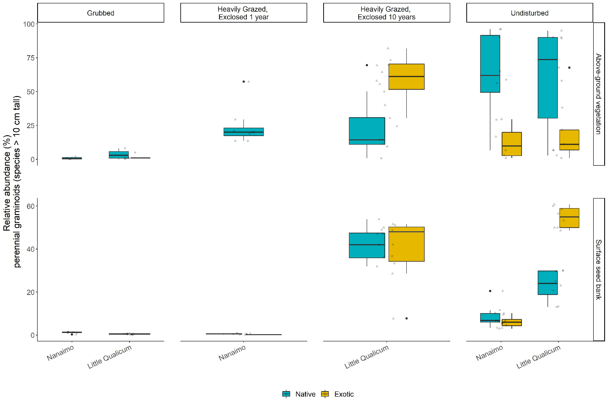

Figure . Above-ground cover abundance of key functional group ‘perennial graminoids (> 10 cm)’ is not significantly different from undisturbed (reference) sites after 10 years. However, indicator species analysis reveals this above-ground cover is dominated by non-native graminoid species Agrostis stolonifera. Moreover, seed bank abundance of tall, perennial graminoids is significantly higher in 10-year old exclosures compared to other disturbance conditions, including undisturbed (reference) sites. Notably, there is nearly equal abundance of non-native and native graminoid seed in 10-year old exclosures, and significantly greater representation of non-native than native graminoid seed in undisturbed sites in Little Qualicum Estuary.

Table . Indicator species analysis identifies which species significantly characterize the above-ground vegetation (left panel) and surface seed bank (right panel) for each disturbance condition, or combination of “recently disturbed” (1-year old exclosures and Grubbed sites) and “recovered” (10-year old exclosures and Undisturbed sites) disturbance conditions. Non-native species are indicated by (*).

|  |  |  |  |  |  |  |
| --- | --- | --- | --- | --- | --- | --- |
| Above Ground Vegetation | | |  | Surface Seed Bank | | |
| **Disturbance** | **Species** | **p-value** |  | **Disturbance** | **Species** | **p-value** |
| Grubbed | *Eleocharis parvula* | < 0.01 |  | Grubbed | *Salicornia depressa* | 0.01 |
| *Cotula coronopifolia\** | 0.04 |  |
| 10-year old exclosures | *Agrostis stolonifera\** | < 0.01 |  | 10-year old exclosures | *Juncus balticus* | < 0.01 |
|  | *Triglochin maritima* | 0.05 |
| Reference | *Juncus balticus* | 0.02 |  | Reference | *Carex lyngbyei* | 0.02 |
| *Carex lyngbyei* | 0.02 |  | *Cotula coronopifolia\** | 0.03 |
| *Triglochin maritima* | 0.04 |  | *Juncus articulatus* | 0.04 |
| 1-year old exclosures + Grubbed | *Spergularia canadensis* | < 0.01 |  | 1-year old exclosures + Grubbed | *Eleocharis parvula* | 0.02 |
| *Glaux maritima* | 0.03 |  | *Spergularia canadensis* | 0.03 |
| 10-year old exclosures + Undisturbed | *Potentilla pacifica* | < 0.01 |  | 10-year old exclosures + Undisturbed | *Agrostis stolonifera\** | < 0.01 |

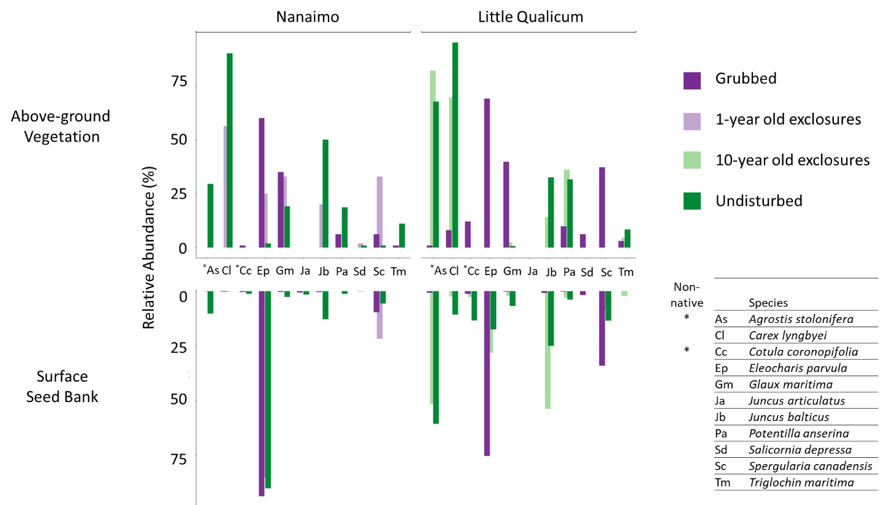

Figure . Relative abundance of species identified by indicator species analysis in above-ground vegetation and surface seed bank at each estuary sampled. Notably, abundance of key native TPGs such as Carex lyngbyei are absent from the seed bank, while others such as Juncus balticus are present in the seed bank but absent in above-ground vegetation, such as observed in 10-year old exclosures at Little Qualicum Estuary.

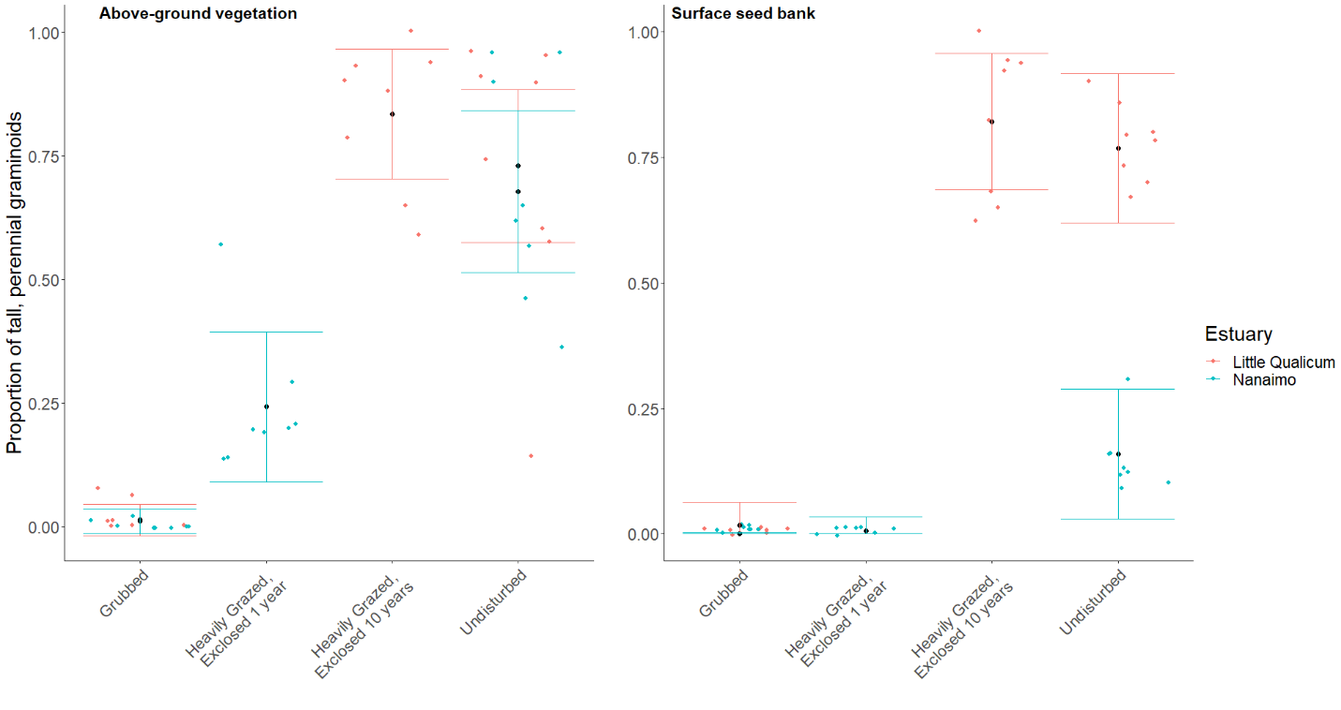

Figure . Actual vs. predicted values for proportion of tall, perennial graminoid in above-ground vegetation cover (left) and surface seed bank samples (right) based on disturbance condition. Actual values plotted as colored points; mean values black points with standard error color coded for each estuary.

# Discussion

1st Paragraph: main messages & framing

1. Main message wrt questions.
2. Why is this important to succession?
   1. Wrt AG TPGs (result example, state support for/against hypothesis)
   2. Wrt BG:AG comparative composition (result example, state support for/against hypothesis)
3. How might succession be altered (broad context; elaborate in 2nd paragraph)?
   1. Alt competitive strategies, invasion of non-native sp., and resulting diversity loss
   2. Novel disturbance (intensive pulse), changing the balance of regenerative capacity in AG/BG.

2nd paragraph: more messages wrt succession

1. Succession favors the competitive dominant species, non-native of concern wrt ecosystem function, and potential trajectory to alt stable state.
   1. AG Result example (paste content from P3 old discussion)
   2. BG:AG, and expectations from the seed bank vs. above ground.
      1. If expected A:B similarity in early succession, and not what we found (Fig), then why?
         1. Speculate on interaction of grubbing/erosion/loss of seed inputs.
         2. What COULD be holding seeds in place (new hypo)
         3. Landscape-scale loss of source population (new hypo)
2. Limitations (paste content last P old discussion)

3rd paragraph: overall implications

1. Ecological memory loss (paste content from P4 old discussion)
   1. presents new questions of ecosystem functionality
2. Passive recovery may be insufficient for native species with a primarily clonal reproductive strategy, especially when non-native species with competitive reproductive advantage of both seed and clonal strategies are present.
   1. Reflect on pass restoration lit (Meli, et al., 2017 – intro)

Closing paragraph: recommendations

1. Management considerations
2. Reconciliation opportunities

## Old discussion

We sought to understand whether dominant ‘tall, perennial graminoids’ (TPGs) recovers following disturbance, and whether surface seed bank composition reflects above-ground vegetation composition. It is evident that extensive grazing and grubbing behavior of Canada geese remove TPGs from the habitat, to the point of converting habitat dominated by rhizomatous TPGs to mudflat characterized by ruderal forbs and short graminoids (Table 2). While it may seem unnecessary to state this change in composition following herbivory, it is important to emphasize that this affects the habitat’s regenerative capacity by removing clonally-reproductive rhizomes and leads to a dearth of native graminoid species in the surface seed bank.

We found that TPG functional group recovered according to our expectations, but with different compositional abundances. Notably, non-native species *Agrostis stolonifera* dominates above-ground vegetation 10 years following grazing exclusion. We found high species richness in grubbed sites and 1-year old exclosures, but low abundance of seed similar to above-ground vegetation except for two species in these disturbance categories (Sp X, Sp Y). This may indicate a loss of propagules in the surface seed bank, either by erosion or inability of the extant vegetation to trap seeds from nearby parent plants or seeds transported by tidal inundation. Our expectations for high similarity between surface seed banks and above-ground vegetation were partially met, however we did not find a strong pattern of dissimilarity increasing with greater time since disturbance.

Whether vegetation is recovering predominantly by vegetative clonal growth, seed recruitment, or a combination of these mechanisms was not tested. Regardless, it appears non-native species are out-competing natives despite some native species’ presence in the surface seed bank and remnant vegetation in the 1-year old exclosures. We found low abundance of seed for some TPG in Undisturbed and 10-year old exclosures, notably a dearth of seed from *C. lyngbyei*. This suggests that if vegetation is disturbed, seeds are not a likely source of propagative material for most species extant in the above-ground vegetation of Undisturbed sites. The two TPG species with greatest abundance in surface seed banks in Undisturbed sites at both estuaries and 10-year old exclosures in Little Qualicum Estuary were native *J. balticus* and non-native *A. stolonifera*. If these two species had comparable competitive traits, we might expect a similar proportion of cover abundance in the above ground vegetation in 10-year old exclosures. This was not the case, suggesting that non-native species *A. stolonifera* has a competitive recruitment advantage during the recovery period. Competitive advantage of *A. stolonifera* may especially be contributing to lack of recovery of seed-limited native TPGs, such as *C. lyngbyei*.

Overall, relative abundance of most native indicator species was lower in the surface seed bank than the relative abundance of their above-ground vegetation counterparts. Over time and sustained disturbance, this may lead to ‘ecological memory loss’ (ref) of native species diversity and compositional abundance as above-ground vegetation is lost to grazing, and subsequently unable to contribute to the surface seed bank. Moreover, as native species’ reproductive mechanisms are lost from the habitat, there is a greater risk of non-native species replacing native species in estuaries. Seed-limited species that rely on clonal reproduction may be at greatest risk for being out-competed if the competitor(s) have greater seed and clonal reproductive rates. We believe we have provided evidence for these processes occurring in the Little Qualicum River Estuary, and this could imply risk of non-native species invasion in younger restoration sites such as those in Nanaimo River Estuary.

Broadly, we may synthesize these findings to recommend areas of attention for habitat managers. Most importantly, the data we present here show that while habitat recovers in terms of plant functional groups, it does not recover the same species compositional abundance in above-ground vegetation or surface seed banks. Thus, passive recovery may be insufficient for native species with a primarily clonal reproductive strategy, especially when non-native species with competitive reproductive advantage of both seed and clonal strategies are present. Whether the non-native species provide the same ecosystem functions such as leaf litter quality for primary productivity, sediment trapping, wave attenuation, etc., remains to be tested (e.g., Waller et al., 2020). Without knowing effects of these changes on habitat quality, best recommendations would be to prevent extensive grazing and grubbing.

Our conclusions must be couched within the limitations of two periods of recovery (1 year, 10 years), each in different estuaries, as well as only one year of seed/vegetation data collection. A major challenge to understanding restoration outcomes is replication of restoration conditions, which should be addressed in restoration design and habitat management. Despite these data limitations, we found evidence suggesting surface seed banks are not a reliable source of abundant native seed species to out-compete non-native species. Propagule dispersal and recruitment limitations cannot rescue native populations if local seed or clonal competitive pressure from non-native species is greater. That is, this trend of both native species loss *and* increasing non-native cover is exacerbated by each species’ competitive dispersal and recruitment strategies. Our best recommendations would be to place a high priority on actively restoring desired tidal marsh species through transplanting, and protecting remnant habitat and new transplants with exclosures to prevent further overgrazing. In instances where disturbance has resulted in extensive estuarine habitat loss, there exists the opportunity to intentionally restore diverse native species palettes, which can remedy trends of biodiversity loss (Lane *et al.*, in preparation). Moreover, this offers a chance to enact reconciliation partnerships with local First Nations to use culturally important species, and potentially restore traditional land management practices (e.g., Turner, 2014).

# Literature Cited

Clements, F. E. (1916). *Plant succession: An analysis of the development of vegetation*. Washington: Carnegie Institution of Washington.

Douglas, G. W., Meidinger, D., & Pojar, J. (Eds.). (1998). *Illustrated flora of British Columbia. Vols. 1-8*. Victoria, BC: B.C. Min. Environ., Lands and Parks, and B.C. Min. For.

Finn, R. J. R., Chalifour, L., Gergel, S. E., Hinch, S. G., Scott, D. C., & Martin, T. G. (2021). Quantifying lost and inaccessible habitat for Pacific salmon in Canada’s Lower Fraser River. *Ecosphere*, *12*, e03646.

Hitchcock, C. L., & Cronquist, A. (1973). *Flora of the Pacific Northwest, an illustrated manual*. Seattle and London: University of Washington Press.

Hopfensperger, K. N. (2007). A review of similarity between seed bank and standing vegetation across ecosystems. *Oikos*, *116*, 1438–1448.

MacArthur, R. H. (1958). Population Ecology of Some Warblers of Northeastern Coniferous Forests. *Ecology*, *39*, 599–619. JSTOR.

Muench, A., & Elsey‐Quirk, T. (2019). Competitive reversal between plant species is driven by species-specific tolerance to flooding stress and nutrient acquisition during early marsh succession. *Journal of Applied Ecology*, *56*, 2236–2247.

Standish, R. J., Hobbs, R. J., Mayfield, M. M., Bestelmeyer, B. T., Suding, K. N., Battaglia, L. L., … Thomas, P. A. (2014). Resilience in ecology: Abstraction, distraction, or where the action is? *Biological Conservation*, *177*, 43–51.

Tilman, D. (2004). Niche tradeoffs, neutrality, and community structure: A stochastic theory of resource competition, invasion, and community assembly. *Proceedings of the National Academy of Sciences*, *101*, 10854–10861.

Turner, N. J., Lepofsky, D., & Deur, D. (2013). Plant Management Systems of British Columbia’s First Peoples. *BC Studies: The British Columbian Quarterly*, 107–133.

Waller, L. P., Allen, W. J., Barratt, B. I. P., Condron, L. M., França, F. M., Hunt, J. E., … Dickie, I. A. (2020). Biotic interactions drive ecosystem responses to exotic plant invaders. *Science*, *368*, 967–972.

# Supplemental

Table . Placeholder example table for species richness in above-ground vegetation plots (veg) and surface seed bank samples (ssb).

|  |  |  |  |  |
| --- | --- | --- | --- | --- |
| **Total Richness** | **Reference** | **Exclosed 10 yrs** | **Exclosed 1 yr** | **Grubbed** |
| Veg | 5 | 5 | 4 | 5 |
| Ssb | 6 | 7 | 8 | 5 |

Table . Placeholder example table for all species presence in the above-ground vegetation (veg) or surface seed bank (ssb) in each disturbance/recovery category.

|  |  |  |  |  |  |
| --- | --- | --- | --- | --- | --- |
| **Species** | **Group** | **Reference** | **Exclosed 10 yrs** | **Exclosed 1 yr** | **Grubbed** |
| a | TPG | Veg, ssb | Veg | Ssb |  |
| b | Other 1 | Ssb | Veg |  |  |
| c | Other 2 |  | Ssb | Veg | Ssb |
| Etc. |  |  |  |  |  |

Table . Frequency (%) of species found in above-ground vegetation plot replicates for Nanaimo and Little Qualicum River Estuaries, combined, ranked by greatest frequency found in undisturbed plots.

|  |  |  |  |  |
| --- | --- | --- | --- | --- |
| **Species** | **Grubbed** | **Exclosed 1 Year** | **Exclosed 10 years** | **Undisturbed** |
| *Carex lyngbyei* | 31.3 | 100 | 100 | 100 |
| *Potentilla pacifica-anserina* | 31.3 | 0 | 87.5 | 87.5 |
| *Agrostis stolonifera* | 18.8 | 0 | 100 | 56.3 |
| *Glaux maritima* | 75 | 100 | 75 | 56.3 |
| *Juncus balticus* | 0 | 12.5 | 62.5 | 56.3 |
| *Triglochin maritima* | 50 | 12.5 | 37.5 | 43.8 |
| *Deschampsia caespitosa* | 12.5 | 37.5 | 0 | 25 |
| *Atriplex patula* | 0 | 0 | 0 | 18.8 |
| *Eleocharis parvula* | 100 | 75 | 0 | 12.5 |
| *Symphyotrichum subspicatum* | 0 | 0 | 0 | 12.5 |
| *Agropyron repens* | 0 | 0 | 0 | 6.25 |
| *Distichlis spicata* | 12.5 | 25 | 0 | 6.25 |
| *Salicornia depressa* | 62.5 | 25 | 0 | 6.25 |
| *Spergularia canadensis* | 100 | 100 | 0 | 6.25 |
| *Trifolium wormskioldii* | 0 | 0 | 0 | 6.25 |
| *Cotula coronopifolia* | 68.8 | 12.5 | 0 | 0 |

Table . Frequency (%) of species found in seed germination replicates for Nanaimo and Little Qualicum River Estuaries, combined, ranked by greatest frequency found in undisturbed samples.

|  |  |  |  |  |
| --- | --- | --- | --- | --- |
| **Species** | **Grubbed** | **Exclosed 1 Year** | **Exclosed 10 years** | **Undisturbed** |
| *Agrostis stolonifera* | 37.5 | 12.5 | 100 | 100 |
| *Juncus balticus* | 62.5 | 75 | 100 | 100 |
| *Spergularia canadensis* | 100 | 100 | 87.5 | 100 |
| *Eleocharis parvula* | 100 | 100 | 50 | 56.3 |
| *Cotula coronopifolia* | 56.3 | 12.5 | 37.5 | 50 |
| *Carex lyngbyei* | 6.25 | 25 | 25 | 43.8 |
| *Juncus tenuis* | 50 | 87.5 | 0 | 37.5 |
| *Potentilla pacifica-anserina* | 6.3 | 0 | 25 | 31.3 |
| *Glaux maritima* | 43.8 | 12.5 | 37.5 | 25 |
| *Juncus articulatus* | 0 | 0 | 0 | 25 |
| *Symphyotrichum subspicatum* | 6.3 | 0 | 0 | 18.8 |
| *Juncus ensifolius* | 0 | 0 | 0 | 12.5 |
| *Achillea millefolium* | 0 | 0 | 0 | 6.3 |
| *Epilobium ciliatum* | 6.3 | 0 | 0 | 6.3 |
| *Epilobium glaberrimum* | 0 | 0 | 0 | 6.3 |
| *Grindelia sp.* | 0 | 0 | 0 | 6.3 |
| *Isolepis cernua* | 18.8 | 0 | 0 | 6.3 |
| *Triglochin maritima* | 0 | 0 | 25 | 0 |
| *Deschampsia cespitosa* | 0 | 12.5 | 0 | 0 |
| *Distichlis spicata* | 0 | 0 | 0 | 0 |
| *Poa palustris* | 6.3 | 0 | 0 | 0 |
| *Salicornia depressa* | 43.8 | 37.5 | 0 | 0 |

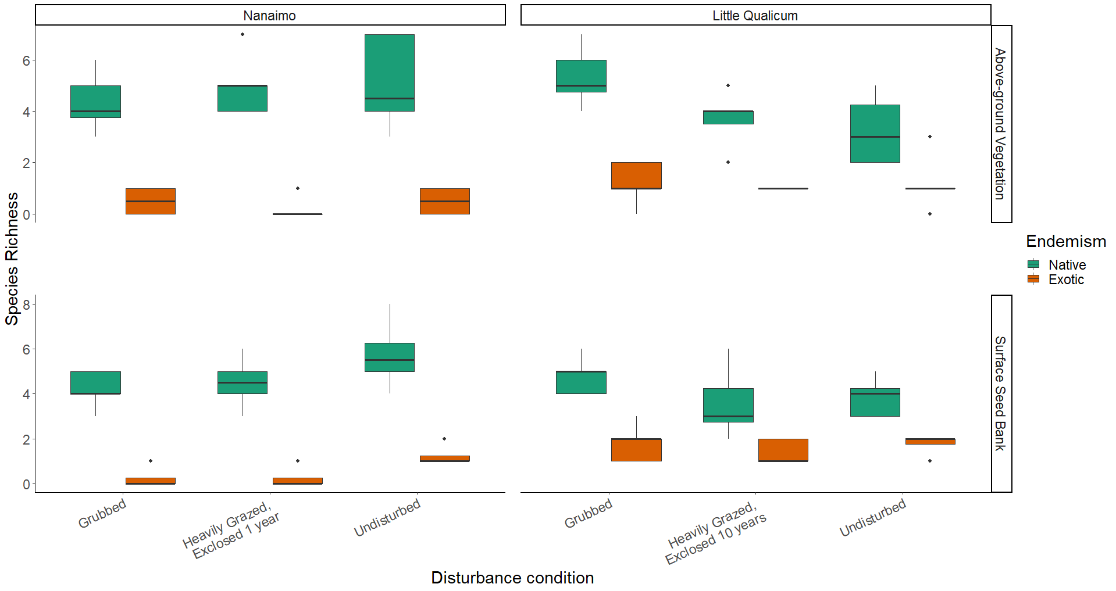

Figure . Native species richness is consistently greater than non-native species richness in both above-ground vegetation and surface seed banks for both estuaries and across all disturbance categories.

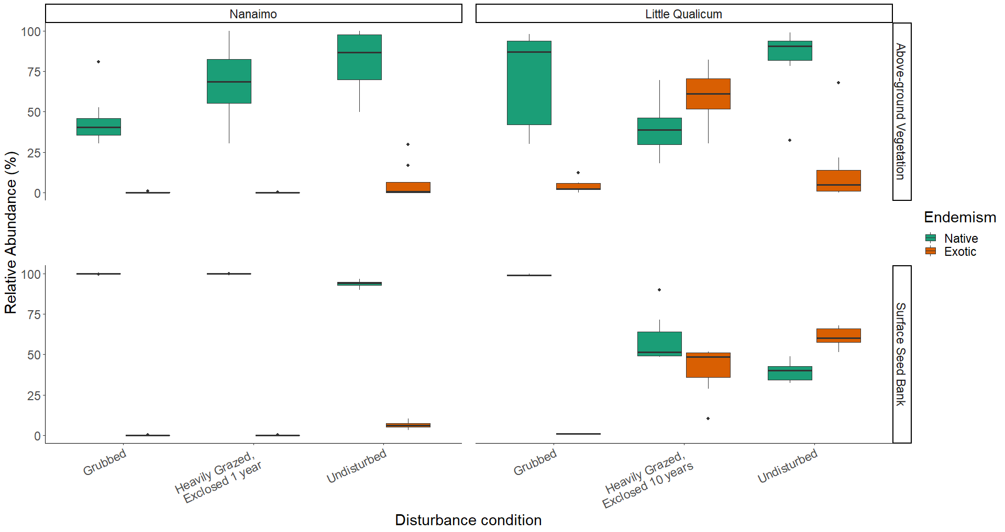

Figure . Above-ground cover abundance of all native species is always significantly greater than all non-native species cover, except in 10-year old exclosures in Little Qualicum River Estuary. Notably, non-native species abundance in the surface seed bank is low across all disturbance conditions in Nanaimo Estuary, but equal to or greater than native species in 10-year old exclosures or undisturbed sites, respectively, in Little Qualicum River Estuary.

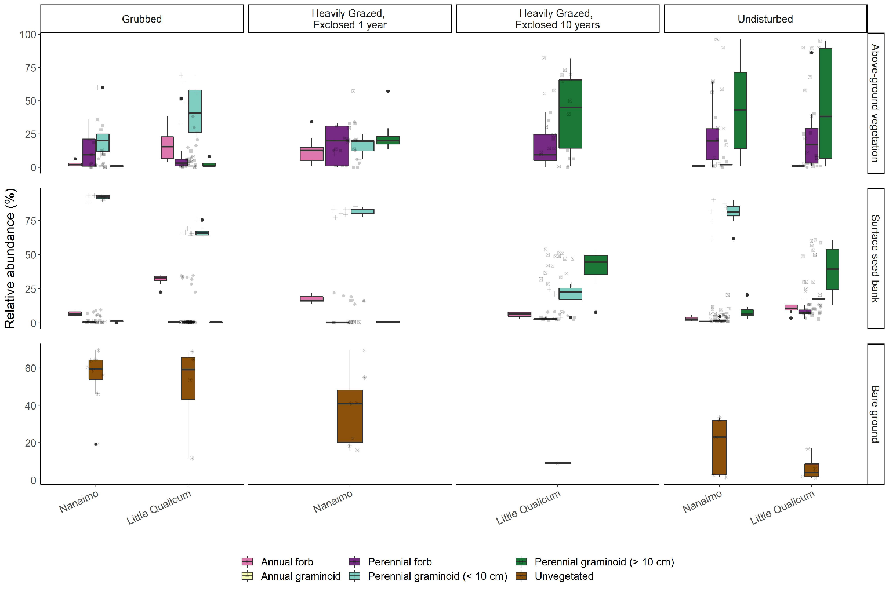

Figure . Recently grubbed and 1-year-old exclosures are dominated by > 50% mean cover of bare ground, with species relative abundance dominated by short perennial graminoid Eleocharis parvula and forbs in both above-ground vegetation and surface seed bank. After 1 year of exclosure, all plant functional groups have similar dominance in above ground vegetation, but surface seed banks do not show increased representation from perennial forbs or perennial graminoids > 10 cm. Bare ground significantly decreases after 10 years of exclosure, while relative abundance of perennial graminoids (> 10 cm) significantly increases in both above-ground vegetation and surface seed banks, not significantly different from undisturbed sites.

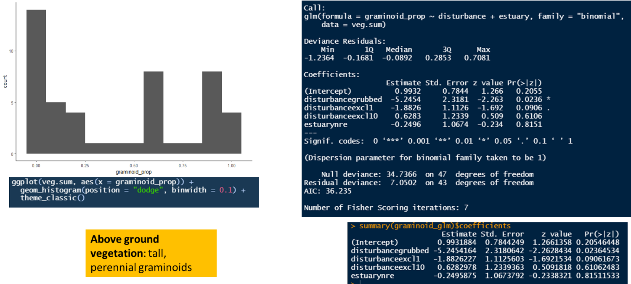

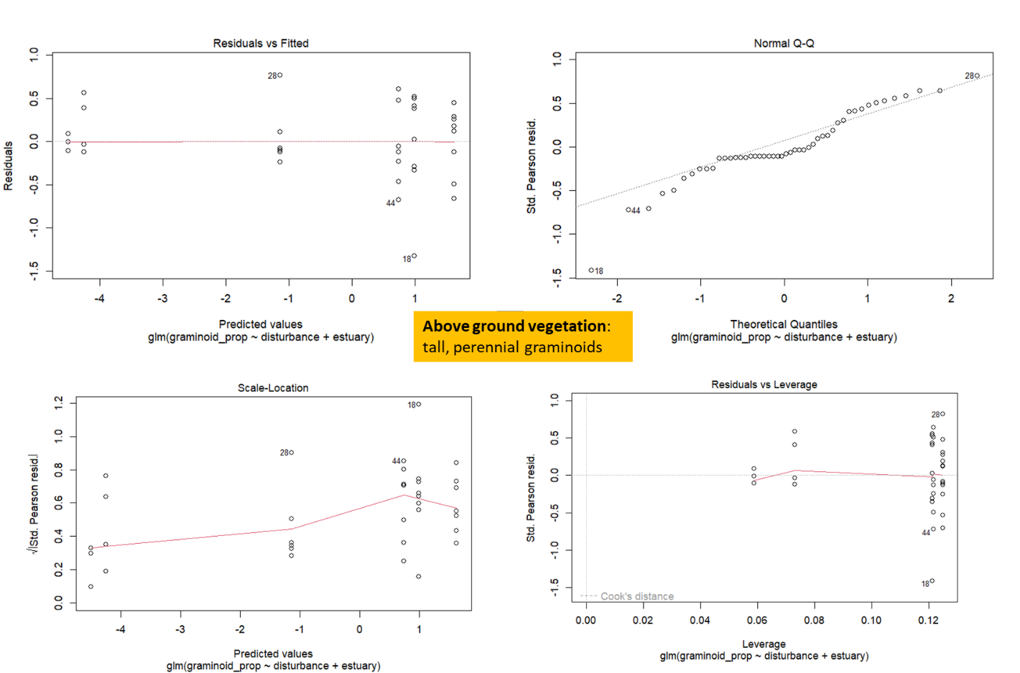

Figure . TEMP FIG - code output for in-text Results reporting glm trends in ABOVE-GROUND VEGETATION. Outliers are individual plots heavily dominated by perennial forbs (especially Douglas aster).

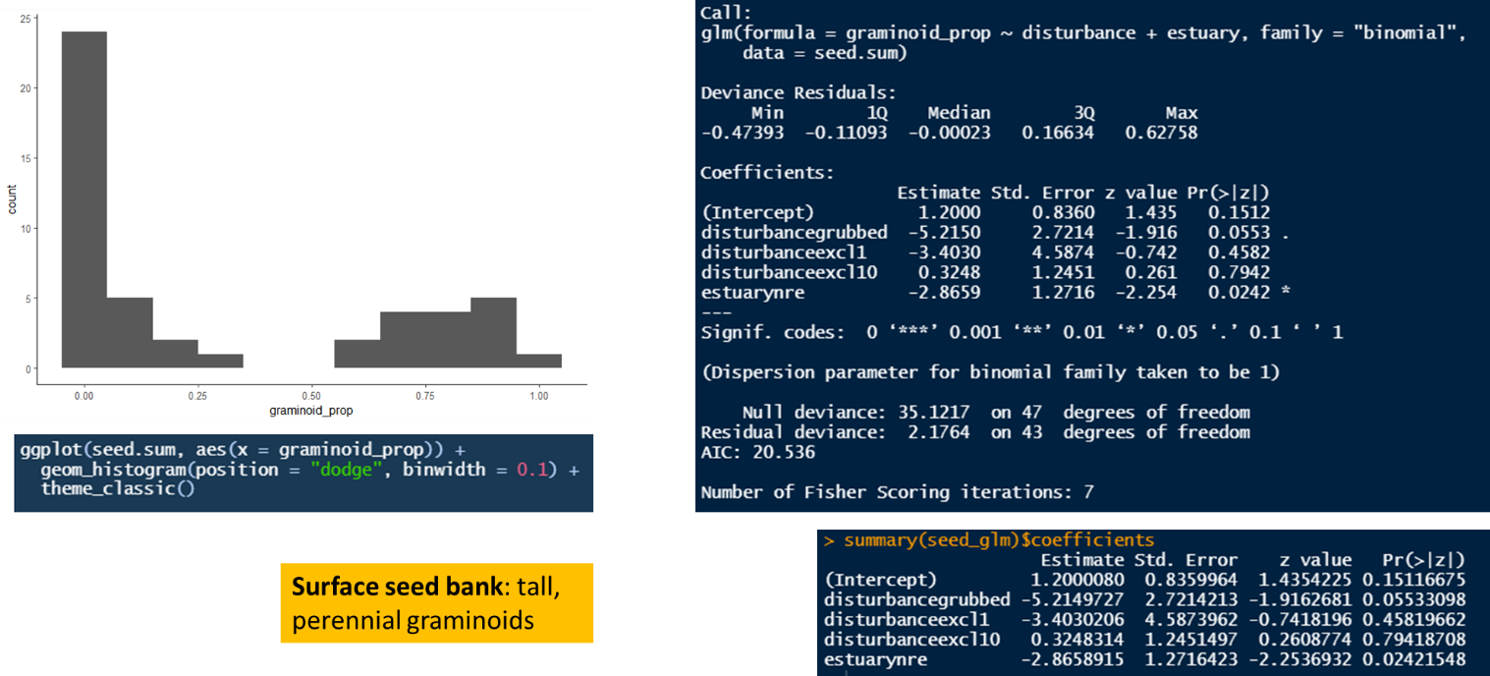

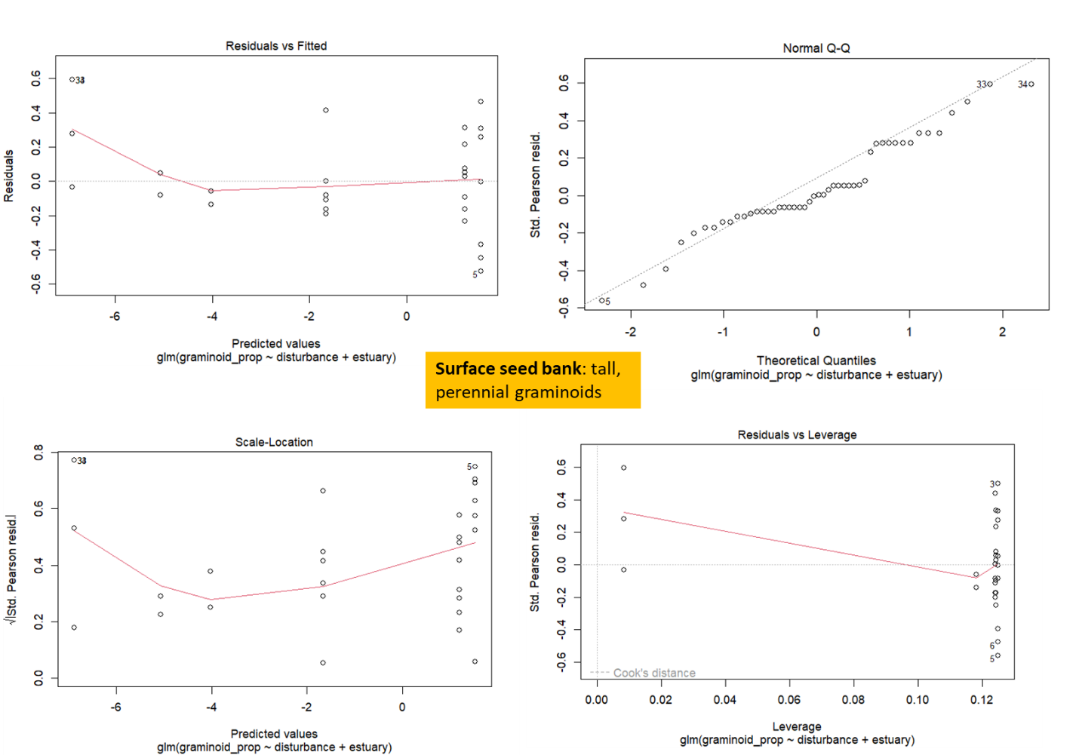

Figure . TEMP FIG - code output for in-text Results reporting glm trends in SURFACE SEED BANK. Outliers are samples dominated by forbs (especially Spergularia canadensis).